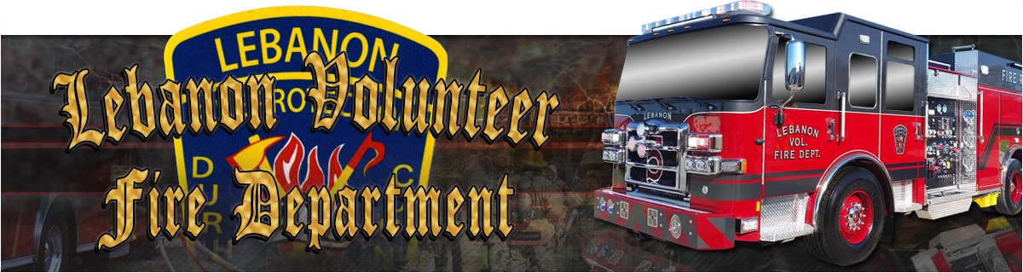

**Application For Membership Part-Time**

**Job Description:**

Perform specialized fire-fighting work in driving and operating firefighting equipment, combating and extinguishing fires, and maintaining equipment. Other duties include assisting with post-fire cleaning and salvage, cleaning fire station and grounds, and attending professional development training.

**Knowledge, Skills, and Abilities:**

Must have knowledge and ability to operate firefighting equipment and administer first aid. Must have ability to communicate effectively with co-workers and the public.

**Part-Timers are Required to have the following:**

* NC Firefighter Level 1 & 2
* NC Hazardous Materials Responder
* Emergency Medical Technician Basic- NC or National Registry
* NIMS 100, 200, 700, and 800
* Emergency Vehicle Driver
* Driver Operator
* High School Diploma or EVD
* Class B Drive`s License

**Attached The Following To This Application:**

* Valid Driver`s License
* Social Security Card
* Copies Of All Certifications

**Lebanon Volunteer Fire Department**

**7900 Russell RD / P.O. Box 71247, Durham, NC, 27712**

**(919) 477-7750**

**1.**

Please Read Completely And Fill Out All Information Before Signing And Summiting

Date Of Application:____________ Part-Time

First Name:___________________MI:____Last Name:____________________________

DOB:________________SSN:____________NCDL:__________________________ Class:____

Address:_______________________________State:____City:_____________County:______________

E-mail:_________________________ Home Phone:______________________

Cell Phone:______________________

Emergency Contact Name:__________________________________________________

Emergency Contact Relation:________________________________________________

Emergency Contact Number:_________________________________________________

Medical History:________________________________________________________________________

Allergies:__________________________________________________________________________________________________________________________________________________________________

Organ Donor: Y___ N___ Blood Type:______________

Health Care Provider:__________________________________________________

Doctors Name:____________________________

Doctors Number:__________________

Employer Name:________________________________________

Employer Address:______________________________________

Employer Phone Number:________________________________

**Lebanon Volunteer Fire Department**

**7900 Russell RD / P.O. Box 71247, Durham, NC, 27712**

**(919) 477-7750**

**2.**

Reference Sheet

Pleas Provide Name, Address, Contact Information, and Relationship to applicant for 3 non-relative references.

1. Name:__________________________

Address:________________________

Phone Number:__________________

Relationship:____________________

1. Name:________________________

Address:_______________________

Phone Number:_________________

Relationship:___________________

1. Name:________________________

Address:______________________

Phone Number:________________

Relationship:__________________

**Lebanon Volunteer Fire Department**

**7900 Russell RD / P.O. Box 71247, Durham, NC, 27712**

**(919) 477-7750**

**4.**

I hereby certify that all the answers and statements in this application are true. I

understand the objective of this department is to provide fire prevention and

preservation of life and property. I will do my best to fulfill this goal. I understand that

any falsification on this application is grounds for dismissal. I understand that this

application will not be reviewed until all components have been received. I understand

the Department has the right to deny membership based on information from

background and/or driving history at the discretion of the Chief or his/her designee. I

understand that as a member of Lebanon Volunteer Fire Department I must abide by

the by-laws and SOG’s of the department.

Signed:______________________________________ Date:______________

North Carolina

County of Durham

The undersigned, being a firefighter in the above County and State,

and recognizing the duties of a firefighter are dangerous and may result in

injury or death, and realizing further that it may be difficult to prove that

death was a result of injuries sustained in the line of duty in order to secure

benefits provided for the survivors:

Therefore, pursuant to G.S. 90-217 in the event I shall die under

circumstances that could possibly be related to firefighting activities, it is

directed that an autopsy be performed on my body and that the results be

made available for any action in connection with the securing of benefits

due to my survivors under Local, State, and/or Federal law.

This the_____, day of_________________, 20______

Signed:______________________________________

**Lebanon Volunteer Fire Department**

**7900 Russell RD / P.O. Box 71247, Durham, NC, 27712**

**(919) 477-7750**

**5.**

( Seal)

North Carolina

County of Durham

I,________________________________, a Notary Public, in and for

said County and State, hereby certify that__________________________,

personally appeared before me, this date and acknowledge the due

execution of the foregoing authorization.

Witness signed and Notary Seal, this the_______day of _______________,20___.

______________________Notary Public Expires:___________

**Lebanon Volunteer Fire Department**

**7900 Russell RD / P.O. Box 71247, Durham, NC, 27712**

**(919) 477-7750**

**6.**